A Tourist Guide of famous Places in India

This is a minor project on travel guide of the famous places around India. in this project we have around 10 different states of India in home page. when the user selects any state, they will see the list of tourist places within that state and also information about that place and any nearby places to visit around it.

About the project:

**Technologies used:** HTML, CSS, Bootstrap, JavaScript, JSON.

**How to run:**

1. Open the project folder in VS code.
2. Go to Home page in vs code, then right click on the page.
3. Select “Open with Live server” option or press “ALT+L+O”
4. The page will open in browser.

**Page 1: Home page**

This is a default page, where we can see title on the top, next we can see carousel/slideshow of images. Below that we can see list of different states in India. the state information coming from json file (**StateInfo.json**) and the respective state icons are stored in path- **“/images/State-icons/”.** If we want to add more state then update the above json file and state icons in the mentioned path.

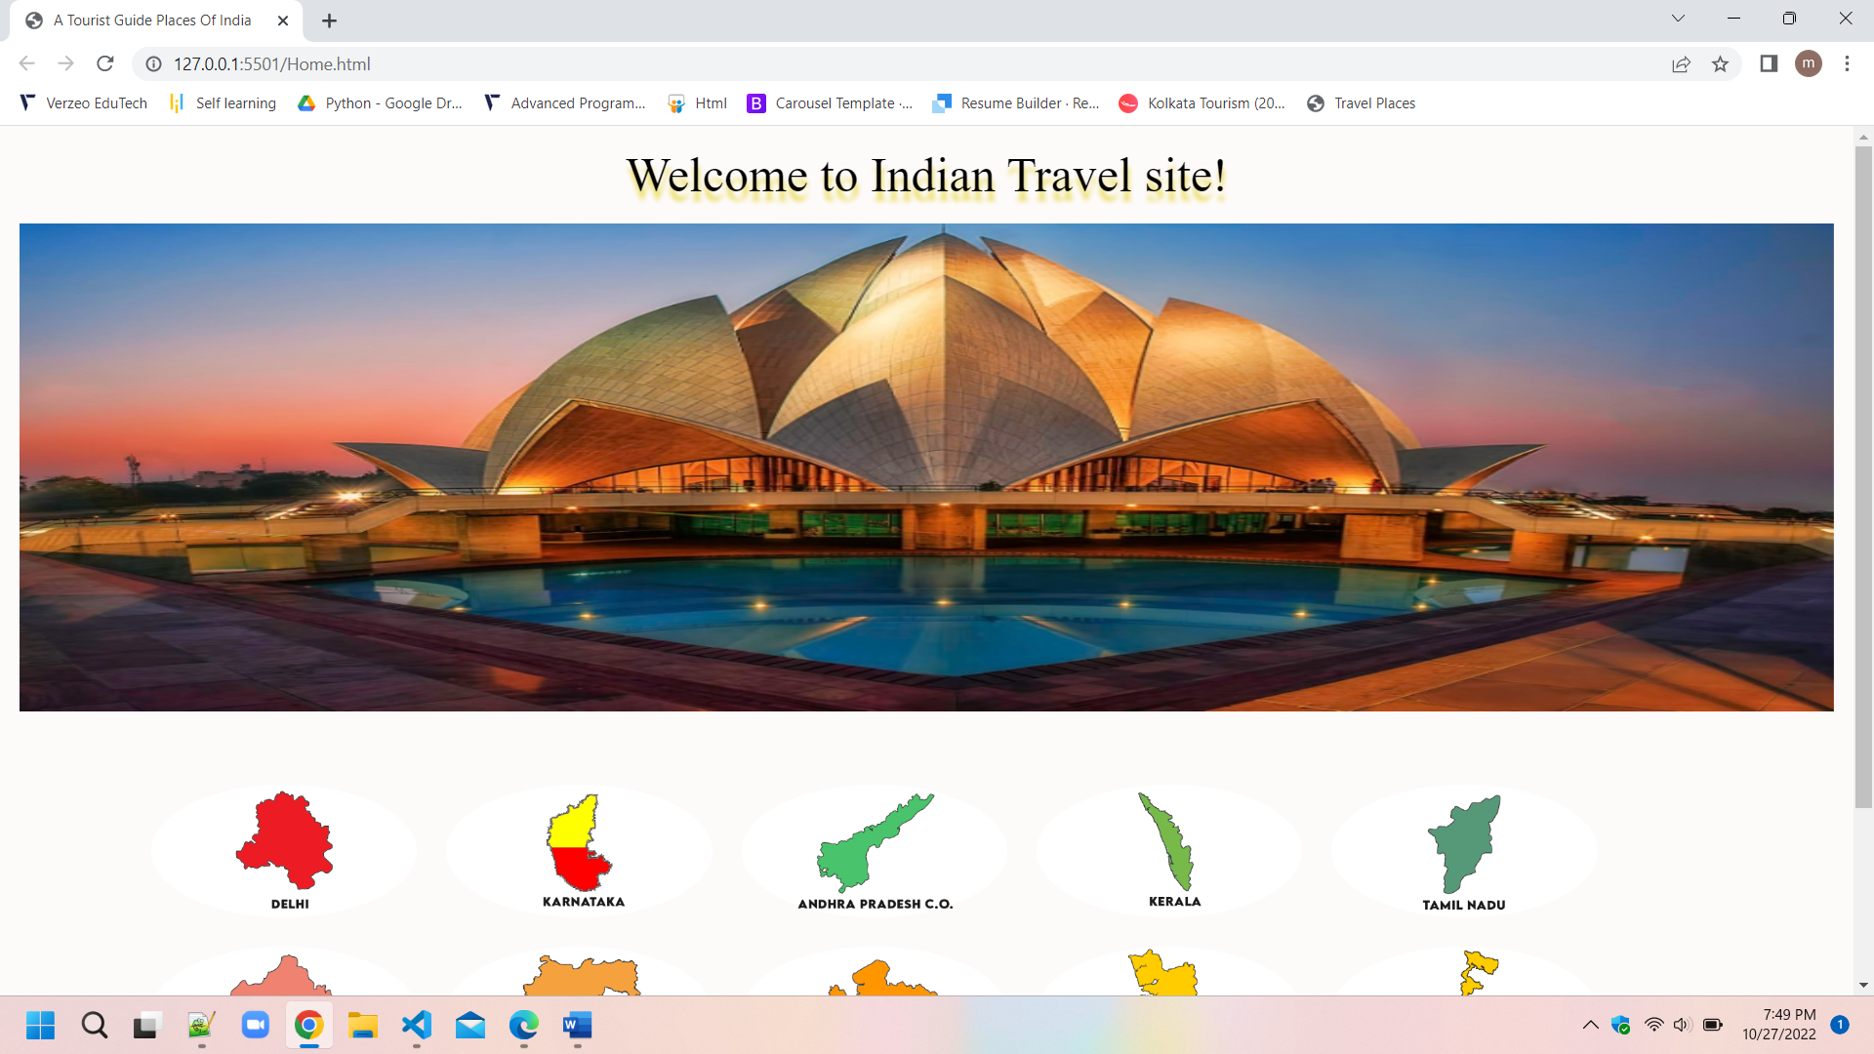

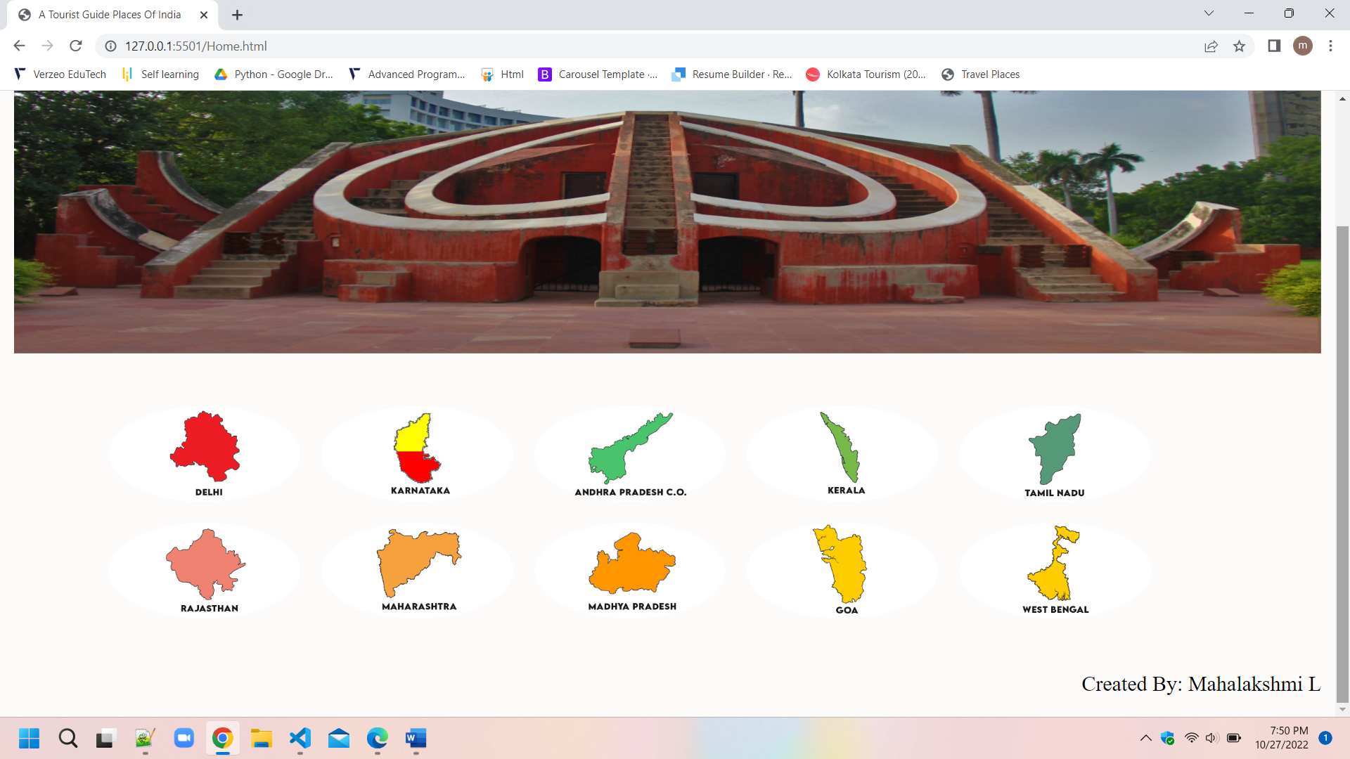

**Page 2: Travel Places page**

In this page we can see list of travel places of a selected city in card format one below the another and also, we can see back to home page button on top right corner of the page and also page title at the center.

The travel places information and image information coming from json (**state.json**) file. In this json file we have the detail information of different travel places information of all states .the places information is picked from json file and display the list of places based on selected state.

If the user wants to go back to home page user can click on Back to home page button.

